

**COMPUTER NETWORKS ASSIGNMENT 01**

**Group Members:**

1. Bilal Ahmed Khan (20k0183)
2. Muaaz Alam (20k0212)

**Task:**

Develop a simple “Chat Messenger” that is connection oriented (i.e. it uses TCP) and that consists of a Client and a Server Program.

1) The Server runs first and waits for some client to contact it.

2) Client Program starts and connects to the server.

3) Client-Server sends and receives messages.

**Libraries Used:**

1. **Tkinter:**

Python library for creating Graphical User interface.

1. **Threading:**

Used to created threads for sending and receiving messages.

1. **Socket:**

For creating sockets for communication between server and clients.

**Working of Program:**

1. **Server Side:**

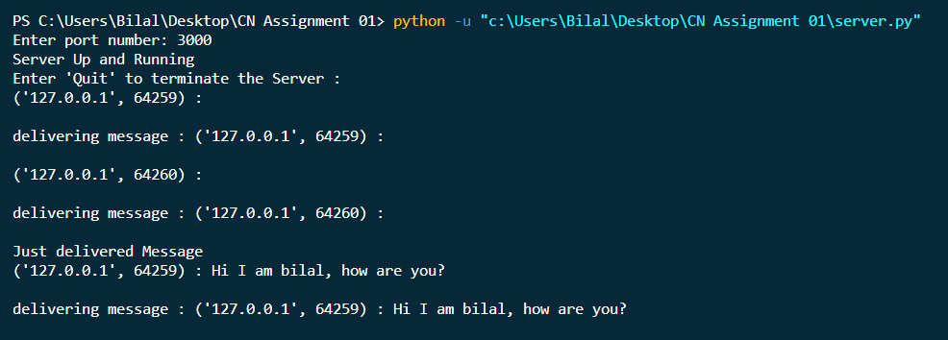

1. **Client Side**

Client 01:

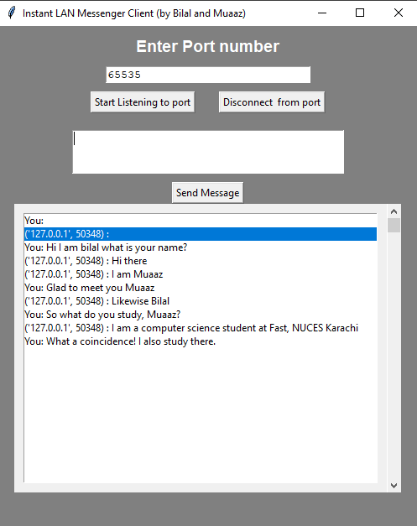

Client 02)

